**PROBLEM STATEMENT**

This program will calculate the end time and cost of a call given the start time, duration, and the different pay rates at certain times of the day.

**Output Display**

Rates

Start Time of Call Rate per minute  
00:00-07:59 0.07  
08:00-18:59 0.12  
19:00-23:59 0.28  
--------------------------------------------------------------------------------

Please enter the Hours (HH) of your start time: 23

Please enter the Minutes (MM) of your start time: 05

Your start time was: 23:05

Please enter the duration of the call in minutes: 120

Your end time was: 1:05

NEXT DAY

The cost of your call was: $33.60

**Structure Chart**

Long Distance Call Program

Cost

**Flowchart**

Start

Pseudo-Code

End

If (1140 <= startTime <= 1439)

If (0 <= startTime <= 479)

If (480 <= startTime <= 1139)

Write formula for cost3

Write formula for cost2

Write formula for cost1

If (endTime > 1440)

**EndTime -= 1440**

**NEW DAY**

if (HH < 0 || HH > 23)  
if (MM < 0 || MM > 59)

Write formula for end time

Write formula for start time in minutes

Prompt user and ask for duration

INVALID

Prompt user and ask for start time

Display rates

1. Display rates
2. Prompt user and ask for start time

-If (HH < 0 || HH > 23) or (MM < 0 || MM > 59) INVALID!

1. Prompt user and ask for duration
2. startTime = (HH * 60) + MM
3. endTime = startTime + duration

-If (endTime > 1440)

Endtime -= 1440

NEW DAY

1. if (startTime => 0 && startTime < = 479)

-cost1 = duration * 0.07

1. if (startTime => 480 && startTime <= 1139)

-cost2 = duration * 0.12

1. if(startTime => 1140 && startTime <= 1439)

-cost3 = duration * 0.28

1.

**INPUT**

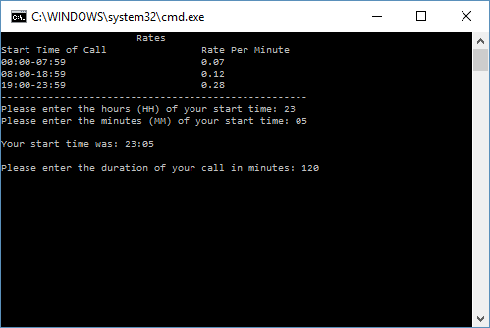

**OUTPUT**

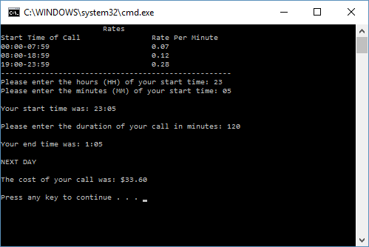

**User Instructions**

This program is designed to calculate what the end time of the user’s call was and the cost of the long distance call given the starting time, the duration of the call, and the rate of the call per minute based on the starting time of the call. To operate the program, first enter the hour (HH) of when you started the call. Then the program will prompt you to enter the minute of your call (MM). The program will then tell you show you the starting time of your call. Now, the program will ask the user the duration of the call in minutes. Simply enter the duration of your call in minutes. The program will then calculate and display the end time of the call and the cost of the call.

**Comment**

Wow this was a doozey of a lab. Working with time in this lab was pretty tricky because hours don’t go above 23 and minutes don’t go above 59 so it was tricky converting time when it goes over those boundaries. I feel really proud successfully completing this lab because there were plenty of moments where I was staring at my computer screen thinking I’d never figure it out. Every single time I kept at it and eventually the light bulb came on. It is a really good feeling knowing that you have the ability to do things you didn’t think you can do.